ComfortDelGro

MCAS - Master table screen dumps for those highlighted

|  |  |
| --- | --- |
| **Screens** | **Beazley Tables** |
| User Group set-up | TM_GroupsM,TM_GroupPermT |
| User Role Type | See #1 |
| User set-up | Tm_users |
| Loss Type | TM_LossType |
| Loss nature | TM_LossNature |
| Workshop Master | See #2 |
| Adjuster Master | TM_Adjusters |
| Surveyor Master | TM_Adjusters |
| Solicitor Master | See #3 |
| Consultant Master | TM_Adjusters |
| Vehicle Make & Model | See #4 |
| Claims Close Reason Master | See #5 |
| Claims Re-open Master | See #6 |
| Currency Master | CurrencyMaster |
| Exchange Rate Master | Currency |
| Insurer Master (Cedant Master) | ~~TM_Reinsurer~~ please re-check the table – see #9 |
| Authority Limits Master | TM_UserDetails |
| Insurance Policy Master | See #7 |
| GST Setting Master | See #8 |

1. User Role Type = user Group in Beazley – I have used different terminology in the SRS

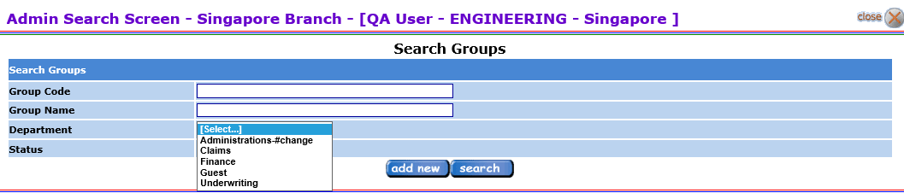

Click “add new”

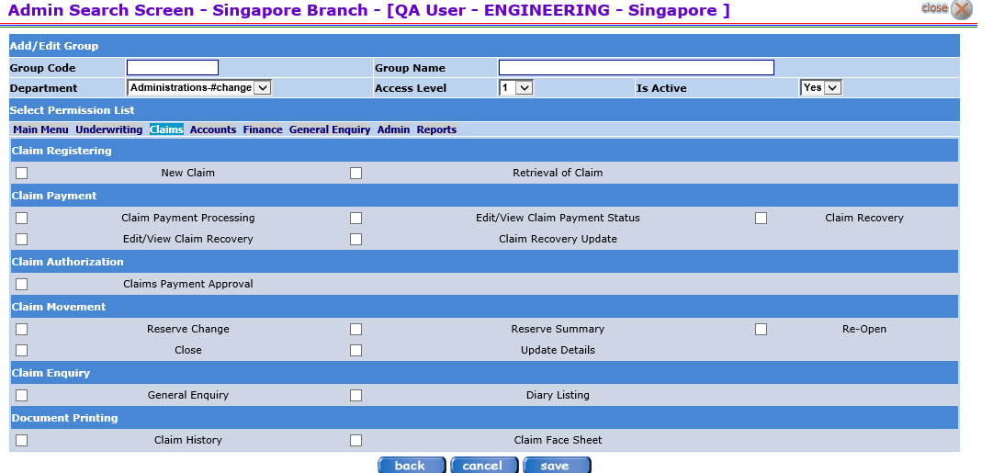

Tick the boxes for which this user group will have access rights to.

Access Level – this is used for peer-to-peer authority level and workflow routing. It has levels 1-10, level 10 being the highest. Logic is that where a user requires a higher level staff to approve an entry/transaction, then, system will use this to determine the next level to assign the approval tasks to.

Looking at the screen, the Department master has to be set up. Please include this, if I had missed this.

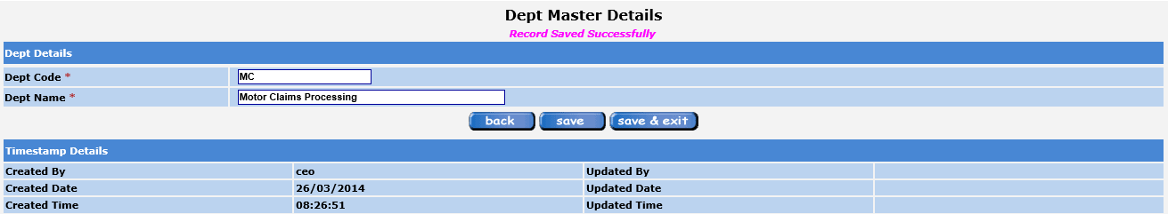

Dept Code – user entry – 2 alpha numeric

Dept Name – User entry – 45 alpha numeric

1. Workshop Master

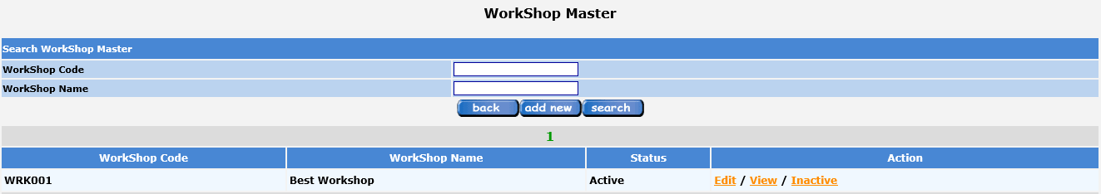

Workshop Code – system generated – WRK001 – 3 alpha(WRK) and 3 numberic starting from 001

Click edit – for a new entry –

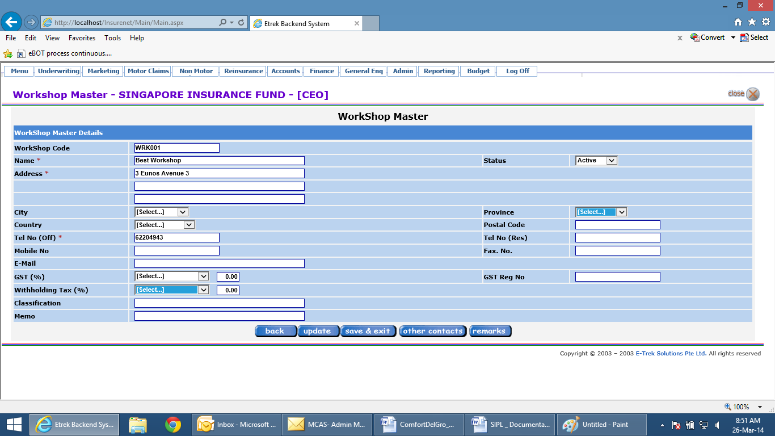

All are user entry fields except where drop-down selections available

Exclude Witholding Tax field – not required – I have blanked it

City – see screen dump below

Province – see screen dump below

Country – see screen dump below – you may set default to Singapore

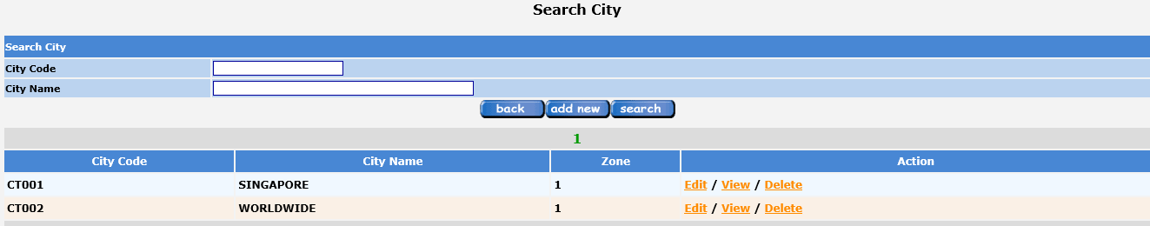

Click “add new” button

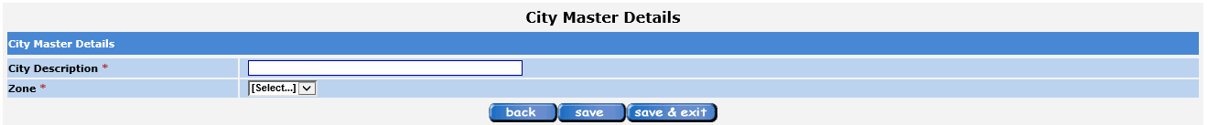

City description – user entry

Zone – not required – I have blanked it

System will generate reference when click on “save”. System code – CT001 in running series

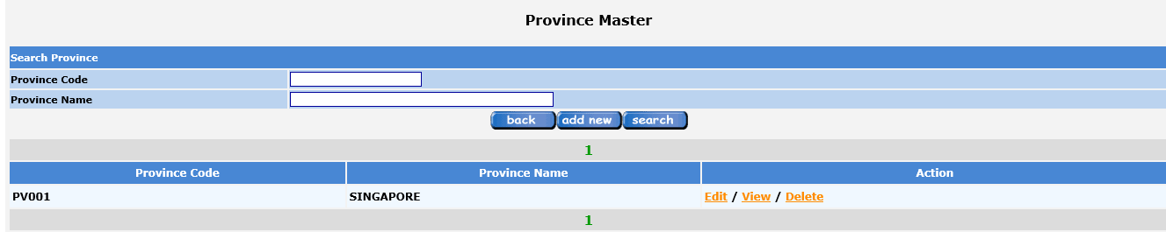

Same design as for City Master

Province code – PV001 in running series

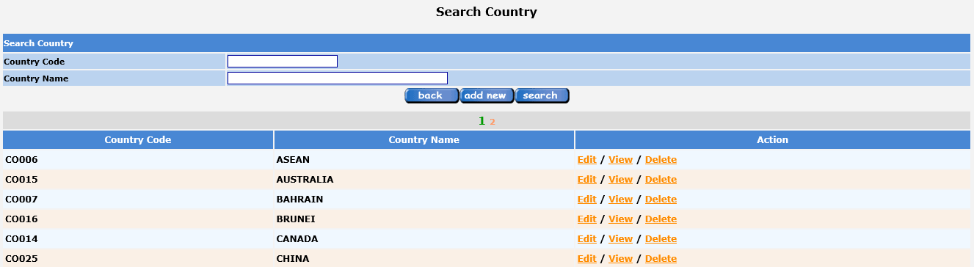

Same design as City Master

Country Cove – CO001 in running series

1. Solicitor Master

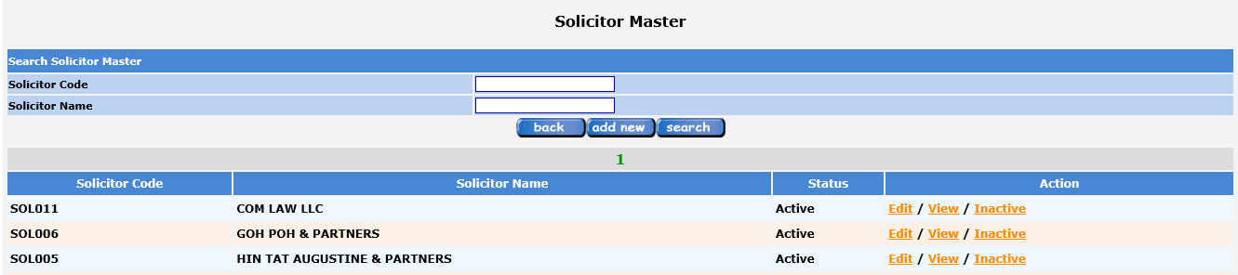

Click “add new”

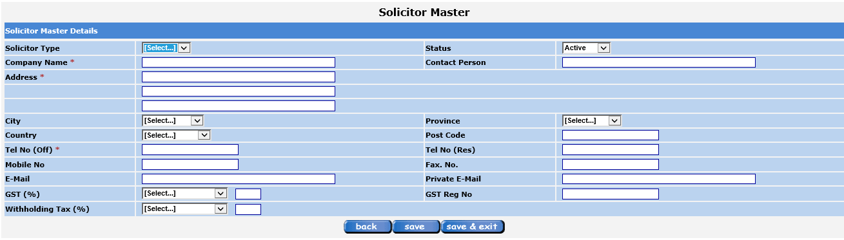

Solicitor type = Local or Foreign

Witholding Tax – to exclude – I have blanked that out

Click “save” system generated reference – SOL001 in running series

1. Vehicle Make & Model

We require 2 separate tables for this data –

Vehicle Make –

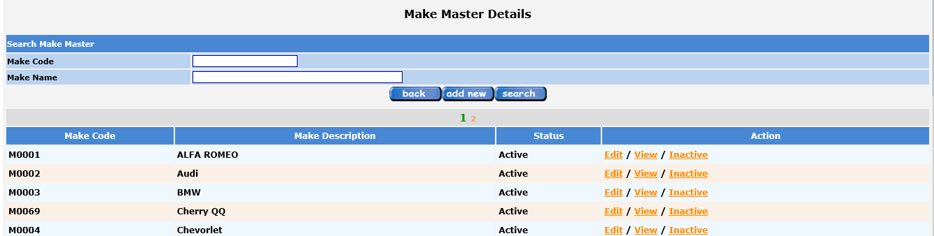

Click “add new” –

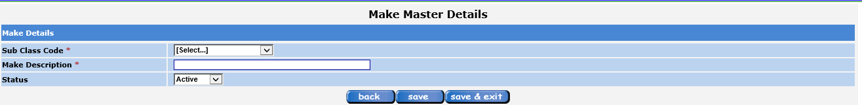

Sub Class Code – drop down box

Make description – user entry – 50 alphanumeric

Status – auto default to Active

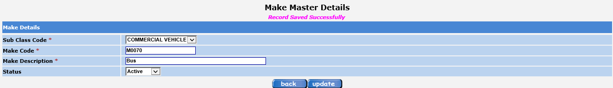

On completion of the fields, click “Save” button, system will generate Make Code – 4 chars – 2 alpha(MC) and 2 numeric(start from 01).

Sub Class Code –

In Beazley, this is = COB Master

COB Master is linked to Main Class Master

1. Claims Close Reason Master

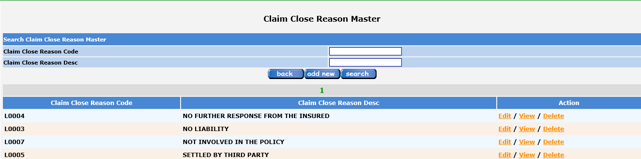

Click “add new” –



Click “save” system generated reference – L0001 in running series

1. Claims Re-Open Master

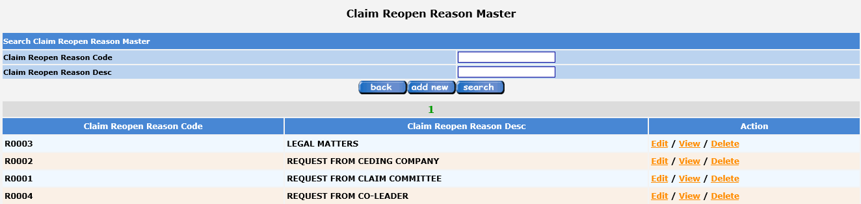

Click “add new” –



Click “save” system generated reference – R0001 in running series

1. Insurance Policy Master

This is a new screen which I need you to design – concept to be consistent with other master tables

The following information to be captured –

Insurer – drop down selection from Insurer Master

Policy No. – user entry – 50 alphanumeric chars

Main Class – drop down selection

Sub-Class – drop down selection

Policy Period Effective from & to

Deductible – Amount or Percentage

Premium – dollar amount, with coma separator

There is a function to add the same block of info for endorsements and new policy period. Validation – no two Policy Nos. can have the same Sub-Class and Policy Period

Business Rules –

1. In claims registration, the system requires validation against an existing policy. This is the area where claims date of accident/loss will be validated against.
2. In entering date of accident/loss, system validates against this table and displays the correct Insurer, Policy No. and Sub-Class
3. GST Setting Master

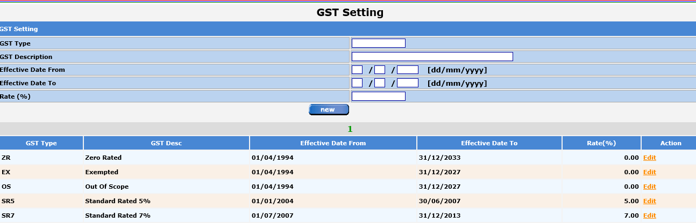

This is found in Finance tab -> Tax Setting

Please use the term GST for MCAS.

1. Insurer Master (Cedant Master in Beazley) – please amend the field name to Insurer Master

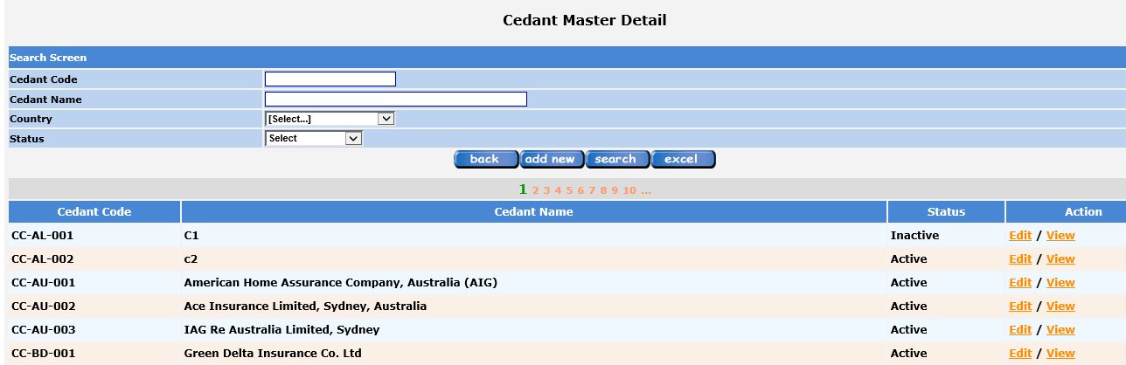

Click “add new”

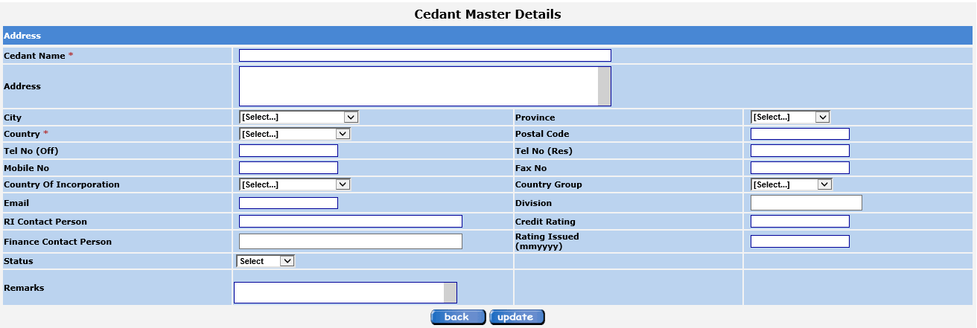

Fields are user entry, except those with drop-down selection.

I have blanked out Country Group – not relevant

Country of Incorporation – read from Country Master